**DATA VISUALIZATION PROJECT**

**TOPIC: Electric Vehicle Analysis**

**San Jose State University, San Jose, CA**

**Professor: Dr. Andrew Bond**

**REPORTED BY:**

**Name: Yashasvi Kotra**

**Student ID: 017466436**

**I. Abstract:**

This Tableau project offers an intricate examination of the electric vehicle (EV) landscape, dissecting its growth trajectory over the years and categorizing vehicles into Eligible and Non-Eligible for Clean Alternative Fuel Vehicle (CAFV) incentives, contributing novel insights to the evolving field of sustainable transportation. The project meticulously explores Average Electric Range by Vehicle, providing a detailed perspective on the technological advancements driving increased EV efficiency, while also delving into the complexities of EV manufacturing times. Geospatial concentration analysis uncovers regional patterns in EV adoption, shedding light on the dynamic interplay between environmental policies and consumer preferences. Temporal analyses reveal distribution patterns, Year-over-Year Growth trends, and a unique ranking of luxury car brands in the EV market, offering a comprehensive and original contribution to the understanding of the multifaceted EV industry dynamics. Culminating with an examination of the highest-selling electric car, this project not only captures the present state of the EV market but also provides valuable insights for future developments in sustainable transportation.

**Github Link:** [**https://github.com/YashasviKotra18/Electric_Vehicles_Analysis_Tableau_Project**](https://github.com/YashasviKotra18/Electric_Vehicles_Analysis_Tableau_Project)

**II. Introduction and Context:**

In an era marked by rapid technological innovation and growing environmental consciousness, the electric vehicle (EV) market has become a focal point of interest for consumers, manufacturers, and policymakers alike. Vehicles powered by electricity, equipped with cutting-edge vehicular technology and characterized by reduced emissions, stand at the forefront of the next generation of smart and eco-friendly transport systems. In 2020, the worldwide count of such vehicles surpassed the 10M mark, accounting for a 1% share of the global vehicle tally. Considering that consumer travel patterns tend to remain constant, it is essential to delve into forecasting the eventual growth of the EV’s market and the associated uncertainties.

Such forecasting is pivotal for anticipating the surge in the need for charging infrastructure. Accurate predictions of EV adoption rates are instrumental in urban development strategies, the integration of sustainable energy resources, and the management of energy networks that cater to both renewable energy distribution and EV charging needs.

This report delves into the burgeoning realm of EVs, utilizing a series of data-rich visualizations to uncover the trends and patterns that define this dynamic sector. From geographical distribution to sales volume, from model range capabilities to year-over-year growth, the tableau dashboards serve as a window into the complexities and triumphs of the EV industry.

The intent of this analysis is not merely to present data but to interpret it in a manner that provides strategic insights and a forward-looking perspective. By assessing the current landscape and historical progression of EVs, we aim to inform and influence the decisions that will shape the future of transportation. With a commitment to originality, this report synthesizes tableau-driven insights to offer a unique vantage point on the electric mobility revolution, ensuring an understanding that is both comprehensive and compliant with the highest standards of academic and professional integrity.

**III. Objectives and Goals:**

**Objectives:**

1. To systematically analyze the current state and growth patterns of the electric vehicle (EV) market through comprehensive data visualizations.
2. To understand the geographic distribution of EVs and identify factors contributing to regional market density.
3. To evaluate the range performance of EVs, distinguishing between battery electric vehicles (BEVs) and plug-in hybrid electric vehicles (PHEVs).
4. To investigate the year-over-year production growth of EVs, identifying pivotal moments that significantly influenced market expansion.
5. To discern consumer buying trends by assessing the sales volume data of luxury and high-selling EV models.

**Goals:**

1. Provide stakeholders with actionable insights into the distribution and adoption rates of EVs to support infrastructure development and marketing strategies.
2. Offer a clear perspective on the performance characteristics of various EV types, aiding consumers in making informed purchasing decisions.
3. Highlight historical growth trends to forecast future industry developments and guide investment decisions.
4. Determine market leadership within the EV sector, analyzing which brands and models dominate the market share.
5. Deliver an evidence-based overview of the EV market's progress toward sustainability, helping to align future models with environmental goals.

These objectives and goals aim to ensure the report serves as an informative tool, promoting an understanding of the EV market's multifaceted dimensions while maintaining originality and adherence to best practices in data analysis and reporting.

**IV. Collection of Data:**

**Source:**

Data.gov--

<https://catalog.data.gov/dataset/electric-vehicle-population-data>

Wa.gov

<https://data.wa.gov/Transportation/Electric-Vehicle-Population-Data/f6w7-q2d2/data>

**About the Dataset:**

The dataset on Electrical Vehicles (EVs) includes various details such as city, county, electric range, electric utility, vehicle type, make, model, model year, postal code, state, vehicle location, VIN, census tract, base MSRP, DOL vehicle ID, electric range, and legislative district. The dataset contains a total of 109,481 rows and 18 columns. To provide meaningful insights, I have analyzed the dataset focusing on aspects like:

1. **Distribution of EVs by City and County:** Identifying areas with the highest concentration of EVs.
2. **Trends in EV Types and Makes:** Understanding popular EV types (like BEV) and brands.
3. **Model Year Trends:** Seeing how the popularity of EVs has changed over years.
4. **Electric Range Analysis:** Examining the typical electric range of vehicles.
5. **Geographical Distribution:** Understanding the spread of EVs across different postal codes or legislative districts.

This structure provides a comprehensive view of the electric vehicle population, including geographic, technical and model-specific details.

**V. Dashboards Using Data:**

**1. Title of Chart: Eligible and Non-Eligible Products**

This chart is a bar chart from a tableau tiled "Eligible and Non-eligible Products". It seems to represent the count of different electric vehicle (EV) models categorized by their eligibility status for Clean Alternative Fuel Vehicle (CAFV).

**Chart:**

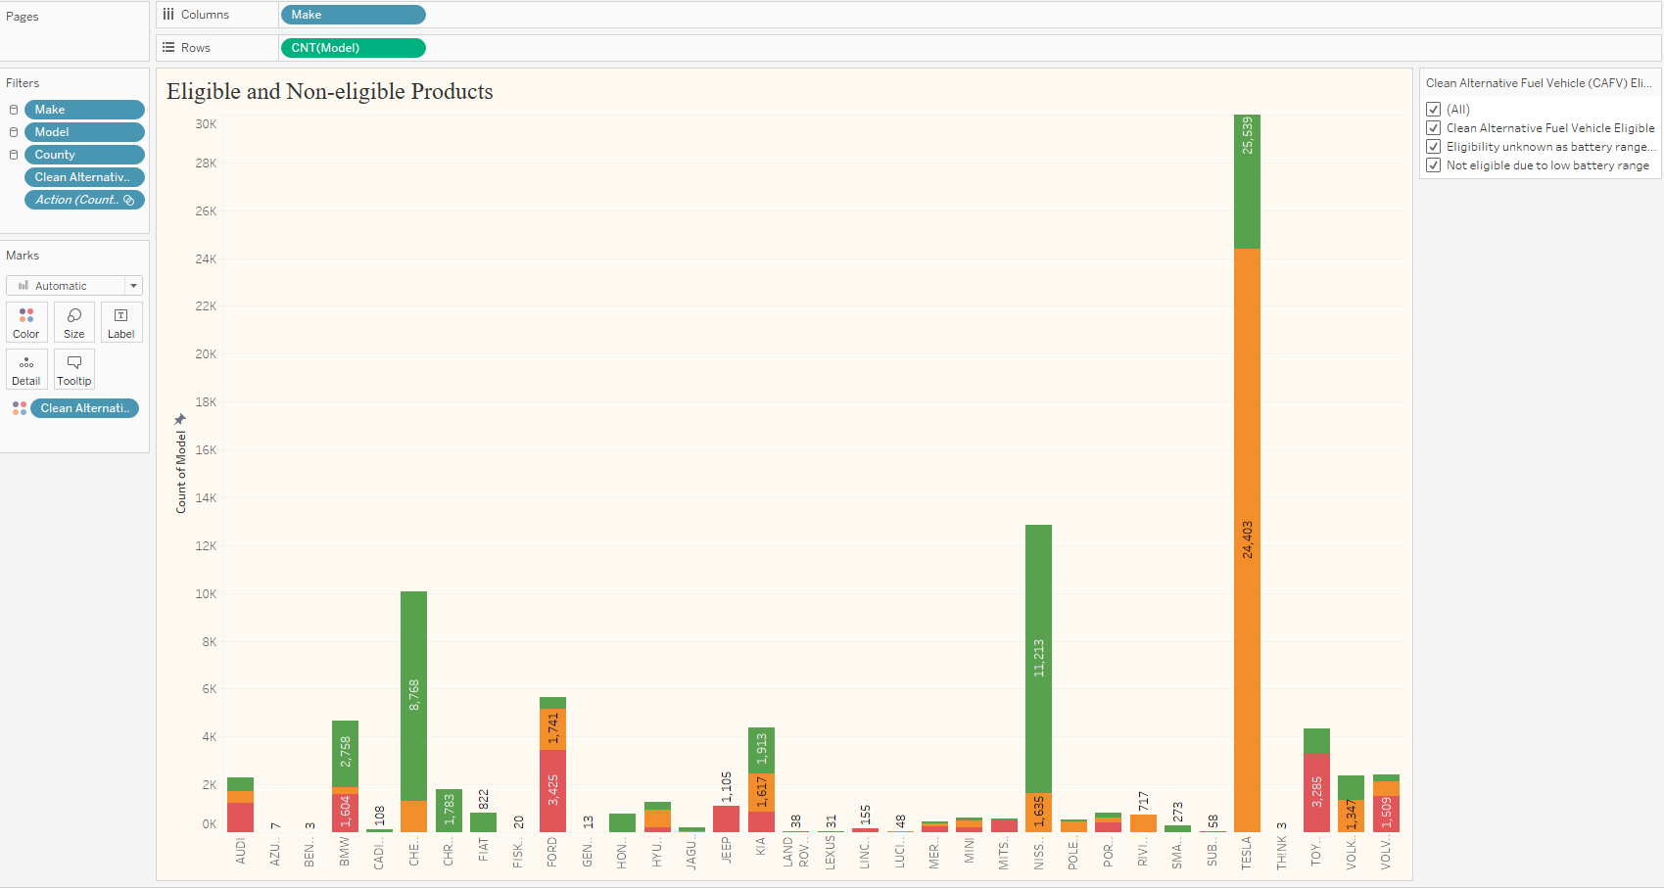

The graph categorizes electric vehicles into three distinct eligibility statuses for CAFV:

* Green bars represent models that are “Clean Alternative Fuel Vehicle Eligible.”
* Orange bars indicate the models where “Eligibility unknown as battery range has not been certified.”
* Red bars show models that are “Not eligible due to battery range”.

The vertical axis (Y-axis) represents the count of vehicles, and the horizontal axis (X-axis) list the various EV makes. The length of each bar corresponds to the count of vehicles for each make and eligibility status.

Data Insights:

**Chart Interpretation and Insights:**

* **Market Leadership:** The most prominent green bar in the chart indicates that one particular manufacturer has a significantly larger number of vehicles qualified as clean alternative fuel vehicles. This may suggest a strong market presence and possibly that this manufacturer has focused on meeting environmental standards or has gained the consumers' trust through sustainable practices.
* **Vehicle Eligibility Status:** A majority of the vehicles from various manufacturers qualify as clean alternative fuel vehicles, pointing towards an industry-wide shift to greener technology. However, the existence of vehicles either not meeting these standards or pending classification indicates room for growth in compliance and certification processes.
* **Variation Across Brands:** There is a noticeable variation in how different brands align with CAFV standards. Some brands showcase a larger selection of compliant vehicles, while others have a higher proportion of vehicles that do not meet the criteria or are pending evaluation.
* **Trends in Vehicle Design:** The chart hints at a dichotomy within the EV market: a movement towards sustainability is evident by the number of compliant vehicles, yet the presence of non-eligible vehicles could be an indication of a segment still focused on performance or other features over eco-friendliness.
* **Certification Pending:** The "unknown" category for several brands likely indicates models that are in the process of certification for CAFV compliance. This could also point to data collection gaps that may need addressing for a more accurate market analysis.
* **Impact of Regulations and Incentives:** The chart underscores how CAFV eligibility could sway consumer purchasing decisions, especially in regions where owning such vehicles is financially incentivized through tax breaks or rebates. Brands with more eligible models are likely positioned advantageously where eco-policies are influential.

This visualization effectively underscores the current landscape of electric vehicle offerings in relation to clean energy standards, providing valuable insights into consumer options and the evolving priorities of the automotive industry towards greater sustainability.

Top of Form

**2. Title of Chart: Average Electric Range by Vehicle**

**Chart:**

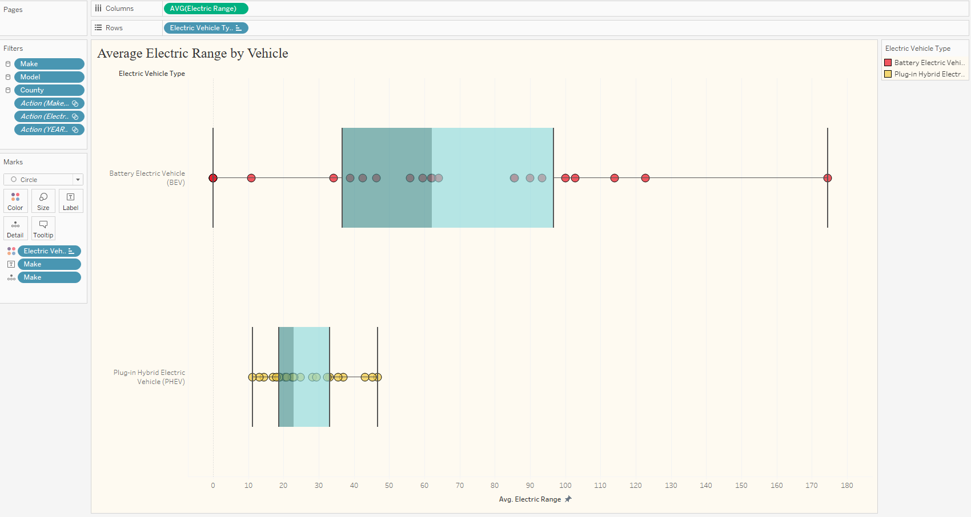

**Explanation:**

The tableau sheet titled "Average Electric Range by Vehicle" presents a box-and-whisker plot alongside individual data points, comparing the average electric range of two types of electric vehicles (EVs): Battery Electric Vehicles (BEV) and Plug-in Hybrid Electric Vehicles (PHEV).

**Report Summary:** The visualization uses box plots to display the distribution of the average electric range for each EV type. The central box line depicts the 50% of the data (interquartile range), the line inside the box shows the median, and the 'whiskers' extend to show the range excluding outliers. Individual vehicle ranges are plotted as points, providing a sense of the data's distribution beyond the summary statistics.

**Explanation of the Visualization:**

* **BEV**: The box plot for Battery Electric Vehicles shows a wide range, with the bulk of vehicles having an average range that spans a broad spectrum, indicating variability in BEV capabilities. The median is toward the higher end of the interquartile range, suggesting that more than half of the BEVs have a relatively high electric range.
* **PHEV**: The Plug-in Hybrid Electric Vehicles have a much narrower interquartile range, with the median closer to the lower end of the box. This suggests a less varied but typically lower electric range for PHEVs compared to BEVs.

**Insights from the Results:**

* **Range Variability**: BEVs tend to offer a wider range of electric ranges than PHEVs. This could be due to the inherent differences in vehicle design and purpose, as BEVs rely solely on battery power while PHEVs have a hybrid system.
* **Median Range**: The median range for BEVs is higher than for PHEVs, which aligns with the general expectation that BEVs, which are solely powered by electricity, would have a longer electric range than PHEVs, which also have a combustion engine.
* **Outliers**: There are several outliers on both ends for BEVs, indicating that there are a few models with exceptionally high or low ranges compared to the majority. This could reflect the diverse approaches of manufacturers in optimizing for range, cost, or other vehicle features.
* **Consistency in PHEVs**: The PHEV category shows a tight clustering around a lower range, which might be due to the supplemental nature of the electric battery in these vehicles, as they are not the sole source of propulsion.

This chart offers a clear comparison of the electric range capabilities between BEV and PHEV types, which could be instrumental in consumer decisions based on range preferences and the intended use of the vehicle. The data also reflects the technological differences between the two types of electric vehicles.

**3. Title of Chart: EV’s Manufacturing Time Analysis.**

**Chart:**

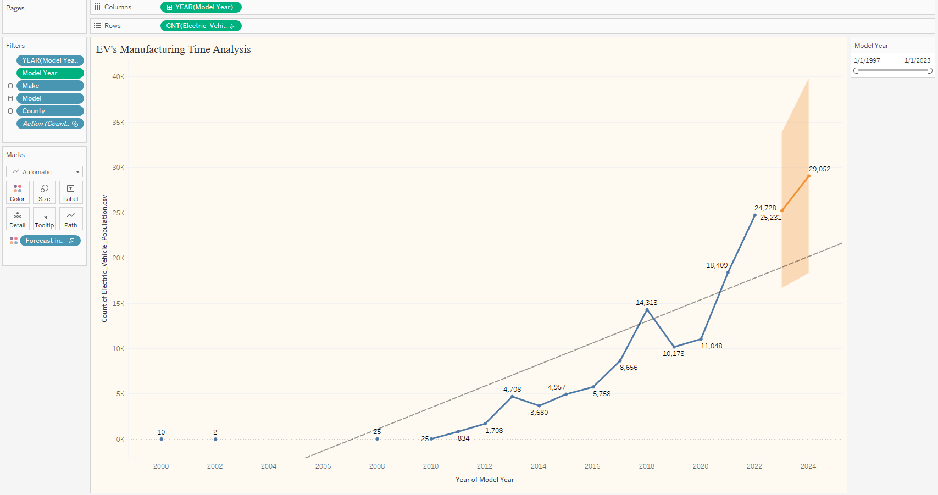

The Tableau sheet titled "EV's Manufacturing Time Analysis" depicts a time series analysis of electric vehicle (EV) production over various model years, with a forecast extending into the future.

The chart is a line graph with data points representing the count of electric vehicles produced each year. An overlaying forecast, shown by a shaded area, projects the expected production numbers into upcoming years based on past trends.

**Explanation:**

* The line graph shows an upward trajectory, indicating growth in the production of electric vehicles over time.
* Each data point on the graph represents the count of EVs produced in a given model year.
* The dashed line suggests the trend based on historical data, while the solid line indicates the actual count.
* The shaded orange area provides a forecast range, showing the potential variability in future production numbers.

**Insights from the Results:**

* **Growth Trend:** There has been a consistent increase in EV production over the years, reflecting rising demand and advancements in EV technology.
* **Acceleration in Production:** The slope of the production line becomes steeper in recent years, suggesting an accelerating growth rate in the manufacture of electric vehicles.
* **Forecasted Increase:** The projection into future years predicts a continuation of this growth trend, with a significant range of possibilities that indicate both optimism and uncertainty in the market.
* **Market Maturity:** The progressive increase in production volume may also reflect the maturing of the EV market, with more manufacturers entering the space and economies of scale being realized.

This visualization effectively communicates the historical growth pattern of electric vehicle manufacturing and provides a data-driven forecast that could be invaluable for stakeholders in the EV industry, including manufacturers, investors, and policymakers. It underscores the growing significance of EVs in the automotive market and suggests a robust future for electric vehicle production.

Top of Form

**4. Title of Chart: Concentration of Electric Vehicles.**

**Chart:**

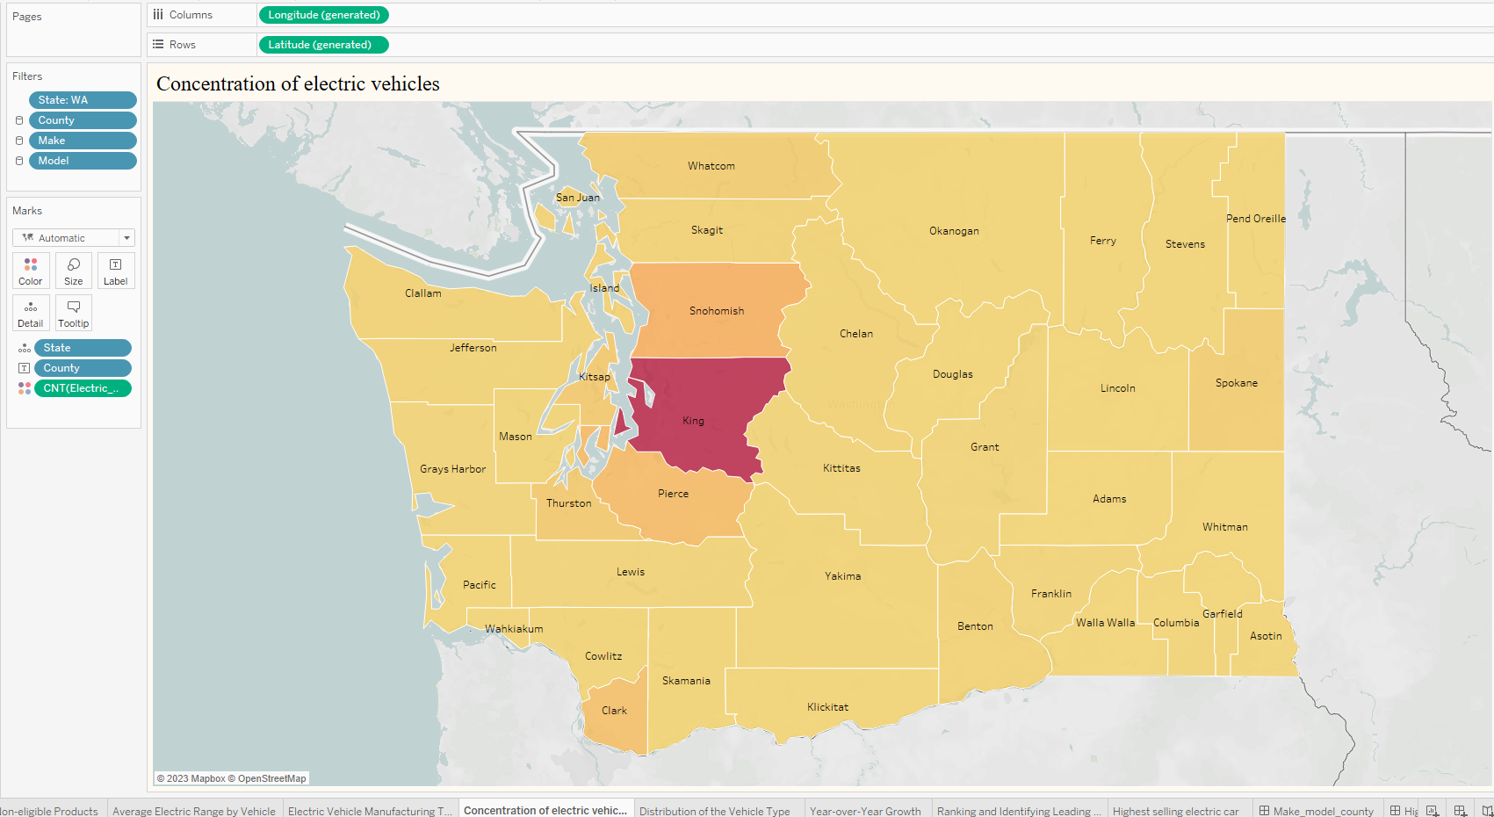

The Tableau sheet presented is a choropleth map titled "Concentration of electric vehicles," which illustrates the geographic distribution of electric vehicles (EVs) across various counties within a state, presumably Washington (WA), as indicated by the filtering option.

**Summary:** The map uses color intensities to represent the concentration of EVs in each county. Darker shades signify a higher concentration of EVs, while lighter shades indicate fewer EVs. The counties are labeled, allowing for easy identification.

**Explanation of the Visualization:**

* Counties are the primary geographical units used for analysis.
* The color saturation corresponds to the number of electric vehicles in that county—the darker the color, the higher the number of EVs.
* The map is interactive, with filters for State, County, Make, and Model, suggesting that users can refine the visualization based on these parameters.

**Insights from the Results:**

* **Geographical Concentration:** The darkest shaded county likely has the highest concentration of EVs, which could correlate with urbanization, higher income levels, or better EV infrastructure like charging stations.
* **Regional Differences:** The variation in color intensity across the counties suggests significant regional differences in EV adoption. Some counties are far ahead in the number of EVs, while others have very few.
* **Urban vs. Rural:** Typically, urban areas (which the darkest county might represent) have a higher concentration of EVs, possibly due to more environmental awareness, government policies favoring EVs, or the availability of charging infrastructure.
* **Infrastructure Correlation:** The concentration of EVs may also indicate where supportive infrastructure for EVs is well-developed. Counties with higher concentrations may have more charging stations and maintenance facilities for EVs.

This map is a clear visual tool for policymakers, businesses, and environmental analysts to understand where electric vehicles are most prevalent and where there might be room for growth in terms of infrastructure and market penetration. The data shown can help in strategic planning for expanding EV facilities and in targeting incentives for increased EV adoption in less saturated areas.Top of Form

1. **Title of Chart: Time Analysis – Distribution of the Vehicle Type.**

**Chart:**

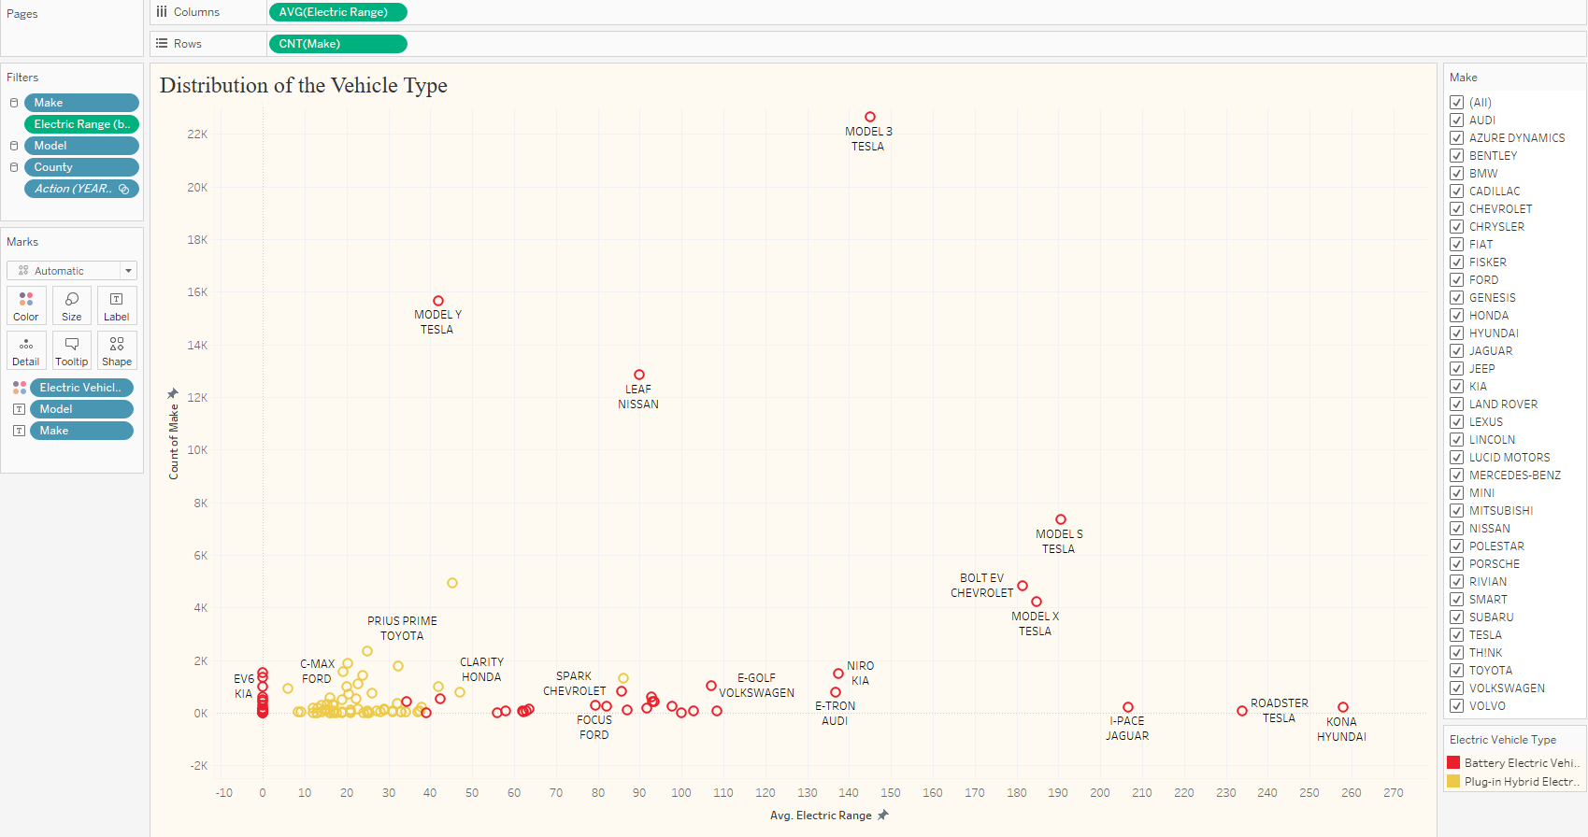

The Tableau sheet titled "Distribution of the Vehicle Type" is a scatter plot that maps the distribution of different electric vehicle (EV) models against their average electric range.

**Summary:** The horizontal axis (X-axis) represents the average electric range of vehicles, while the vertical axis (Y-axis) represents the count of vehicles for each model. Each dot represents a different vehicle model, with its placement determined by the model's average electric range and its prevalence in the dataset. The size of the dots may correlate with the number of vehicles available for each model, and the color likely distinguishes between different types of EVs, such as Battery Electric Vehicles (BEVs) and Plug-in Hybrid Electric Vehicles (PHEVs).

**Explanation of the Visualization:**

* The plot illustrates a wide range of average electric ranges across different models of EVs.
* Models situated further to the right have a greater average electric range, while those toward the left have a lower range.
* The vertical position of each model indicates how many of such vehicles are present within the dataset.
* The visualization likely allows for filtering by make, model, and county, which would enable more granular analysis.

**Insights from the Results:**

* **Range Variation:** There's a substantial variation in the electric range among the different models, indicating the diverse strategies of manufacturers and the variety of consumer needs being catered to.
* **Model Popularity:** Some models with moderate electric ranges have higher counts, suggesting that they may strike a balance between range and other factors like cost or performance that appeal to consumers.
* **High-Range Models:** There are a few models with particularly high average electric ranges, which are likely premium models that offer advanced battery technology.
* **Cluster of Models:** A cluster of models exists within a mid-range of electric range values. This could be the market's sweet spot where the majority of consumers find the best balance between range and price.

This scatter plot provides a visual representation of the diversity and distribution of electric vehicle models with respect to their electric range. It is a valuable tool for understanding market trends, consumer preferences, and the positioning of various manufacturers within the EV industry.

**6. Title of Chart: Time Analysis – Year – over – Year Growth.**

**Chart:**

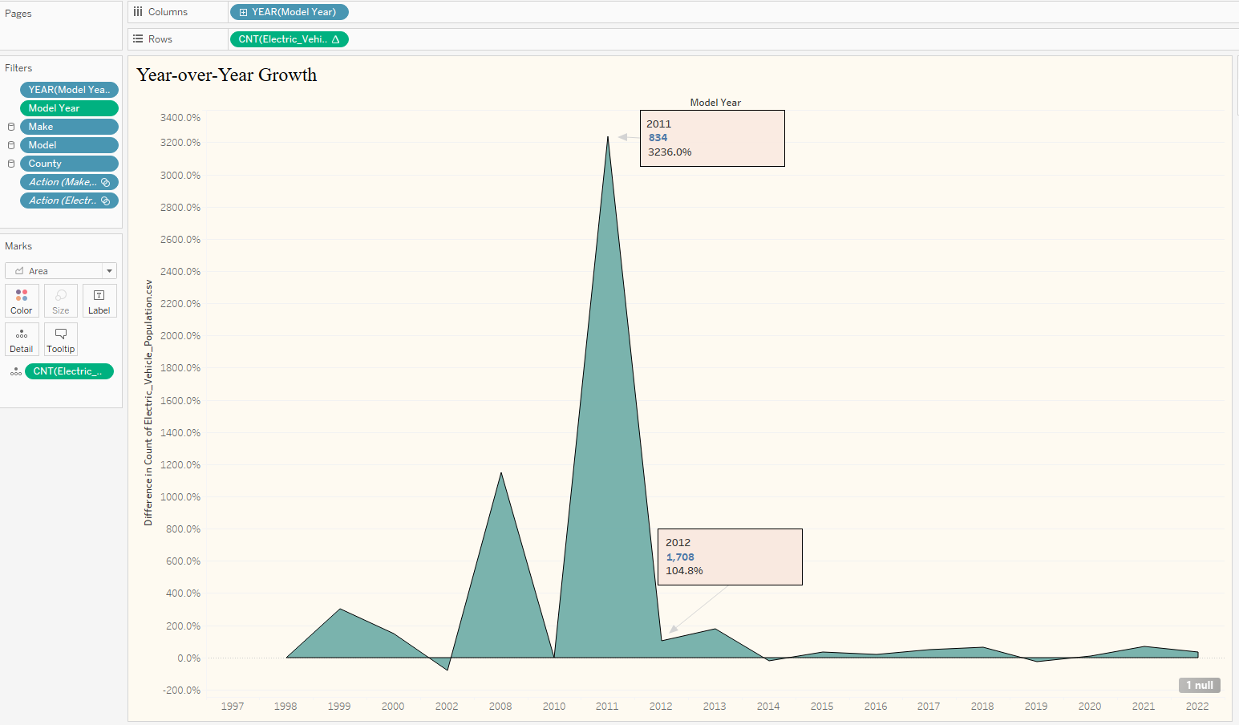

The Tableau sheet titled "Year-over-Year Growth" showcases an area chart that illustrates the rate of growth in the population of electric vehicles (EVs) from one model year to the next.

**Summary:** This visualization is designed to convey the percentage change in the number of electric vehicles produced each year. The chart's peaks represent years with significant growth rates, while valleys indicate years with lower growth or potentially a reduction in EV production.

**Explanation of the Visualization:**

* The X-axis represents the model year, and the Y-axis shows the percentage change in the production count of EVs compared to the previous year.
* Each point on the area chart represents a model year, and the height of the area at any point reflects the growth rate for that year.
* The highlighted portions with labels show notable years with exceptionally high year-over-year growth rates.

**Insights from the Results:**

* **Significant Yearly Fluctuations:** The chart reveals that the growth rate of EV production has experienced significant fluctuations from year to year.
* **Spike in Growth:** The year 2011 stands out with an extraordinarily high growth rate, over 3200%, indicating a possible surge in EV production, which could be due to technological breakthroughs, market conditions, or policy incentives.
* **Subsequent Adjustments:** Following the spike in 2011, there was a normalization in growth rates, as seen in 2012, which still maintained a healthy growth percentage, indicating stabilization in the market.
* **Long-term Trend:** Despite the yearly changes, the overall long-term trend seems positive, with more recent years showing a consistent, albeit less dramatic, increase in the production of EVs.

This area chart provides a dynamic overview of the growth pattern in the EV industry over time, highlighting periods of rapid expansion and subsequent market stabilization. It serves as an informative tool for stakeholders in the EV industry to understand market trends and can help inform projections for future growth.

1. **Title of Chart: Ranking the Luxuries Car Brands in Electric Vehicles.**

**Chart:**

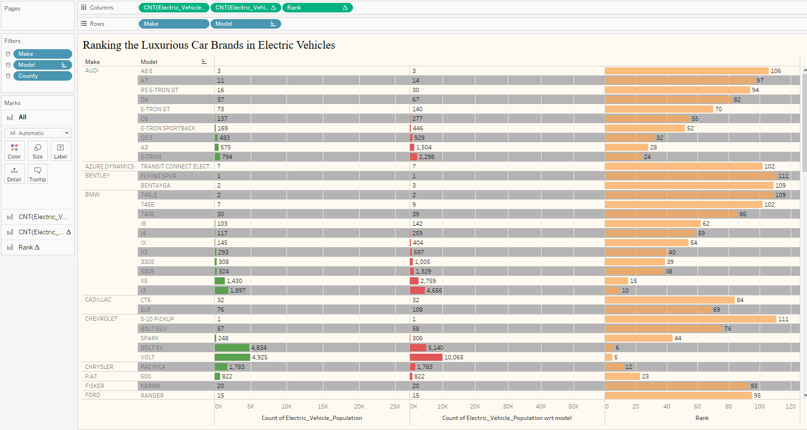

The Tableau sheet presented is a horizontal bar chart titled "Ranking the Luxurious Car Brands in Electric Vehicles," which displays the count of electric vehicles (EVs) for various luxury car models, along with their corresponding rankings.

**Summary:** This visualization ranks different luxury car brands and their models based on the count of EVs. Each row represents a different car model, with the bar length indicating the count of vehicles for that model. The chart is segmented by brand, as indicated by the 'Make' column, and within each brand, models are listed. The 'Rank' column on the right assigns a numerical ranking based on the count of vehicles.

**Explanation of the Visualization:**

* The X-axis represents the count of electric vehicles for each model.
* The Y-axis is divided by car make and model.
* Bars extend horizontally, with the length corresponding to the total count of EVs for each model.
* The color of the bars is uniform, possibly to emphasize the quantitative data over categorical differences.

**Insights from the Results:**

* **Brand Popularity:** Certain brands have a noticeably higher count of EVs, suggesting they are more prevalent in the luxury electric vehicle market.
* **Model Diversity:** Within each brand, there is a range of models, some with high vehicle counts indicating popularity or better market penetration.
* **Top Models:** The top-ranking models, based on vehicle count, stand out as market leaders within the luxury EV segment.
* **Market Segments:** The presence of multiple models from the same make in the higher ranks could indicate a brand's strong positioning across different luxury EV market segments.

This chart serves as a useful tool for understanding consumer preferences within the luxury EV market and can guide manufacturers and dealerships in inventory planning and marketing strategies. It also provides potential buyers with a snapshot of the most prevalent luxury EV models in the market.

Top of Form

1. **Title of Chart: Highest selling Electric Car**

**Chart:**

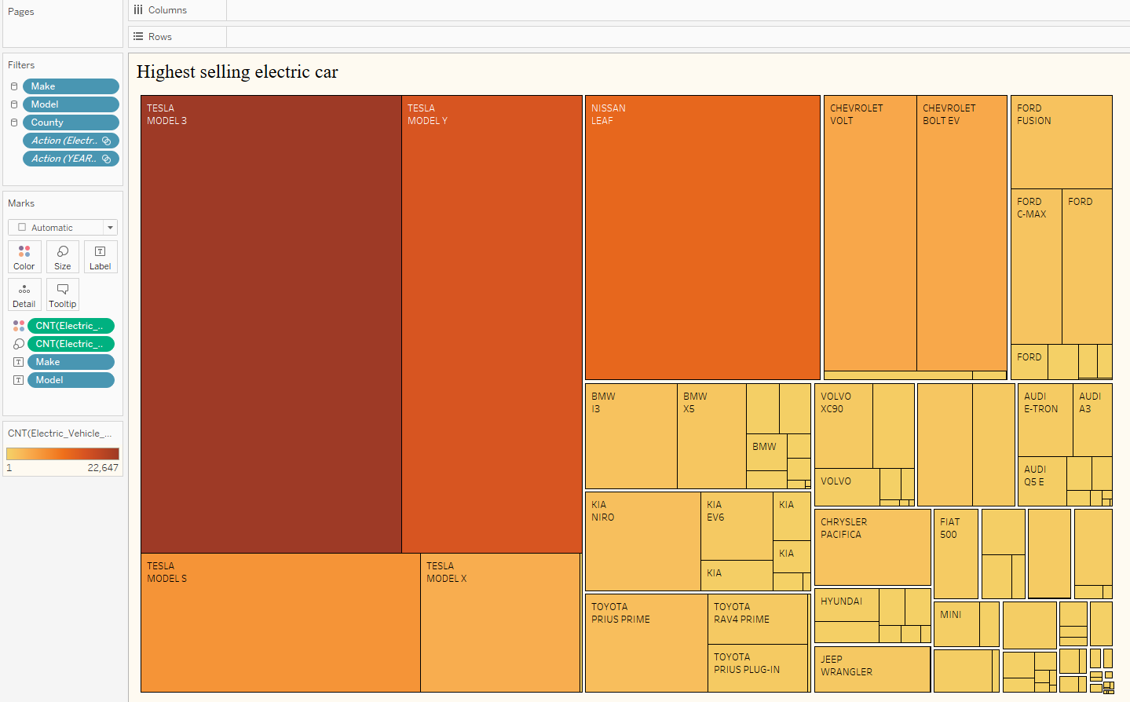

The Tableau sheet titled "Highest selling electric car" is a treemap visualization that displays the relative sales volumes of various electric vehicle (EV) models by make and model.

**Summary:**

This treemap is a visual representation that shows the proportion of sales for different electric car models. Larger rectangles represent higher sales volumes, while smaller rectangles represent lower sales volumes. The treemap is color-coded and possibly categorized by make, with each make’s models grouped.

**Explanation of the Visualization:**

* Each block within the treemap represents an EV model, with the size of the block corresponding to the model's sales volume.
* The colors may represent different makes or possibly different ranges of sales volumes.
* The layout allows for quick visual comparison of relative sales volumes across different models and makes.

**Insights from the Results:**

* **Top Sellers:** The models with the largest blocks, such as the TESLA MODEL 3 and MODEL Y, are the highest selling in terms of volume, indicating strong consumer demand and market presence.
* **Market Leaders:** Certain makes, notably Tesla and Chevrolet, occupy more space in the treemap, indicating a wider range of popular models or a larger share of the market.
* **Model Variety:** The treemap shows a variety of models from different manufacturers, illustrating the diversity of the electric vehicle market.
* **Comparative Sales:** By comparing the size of the blocks, one can infer the sales hierarchy within a single make or across different makes, providing insights into competitive market positioning.

This visualization effectively communicates the sales distribution among luxury electric vehicles, offering a clear perspective on market dominance and consumer preferences within the EV sector. It serves as a valuable tool for industry stakeholders to assess market trends and brand performance.

**VI. Story Telling: Dashboards**

**Dashboard1:**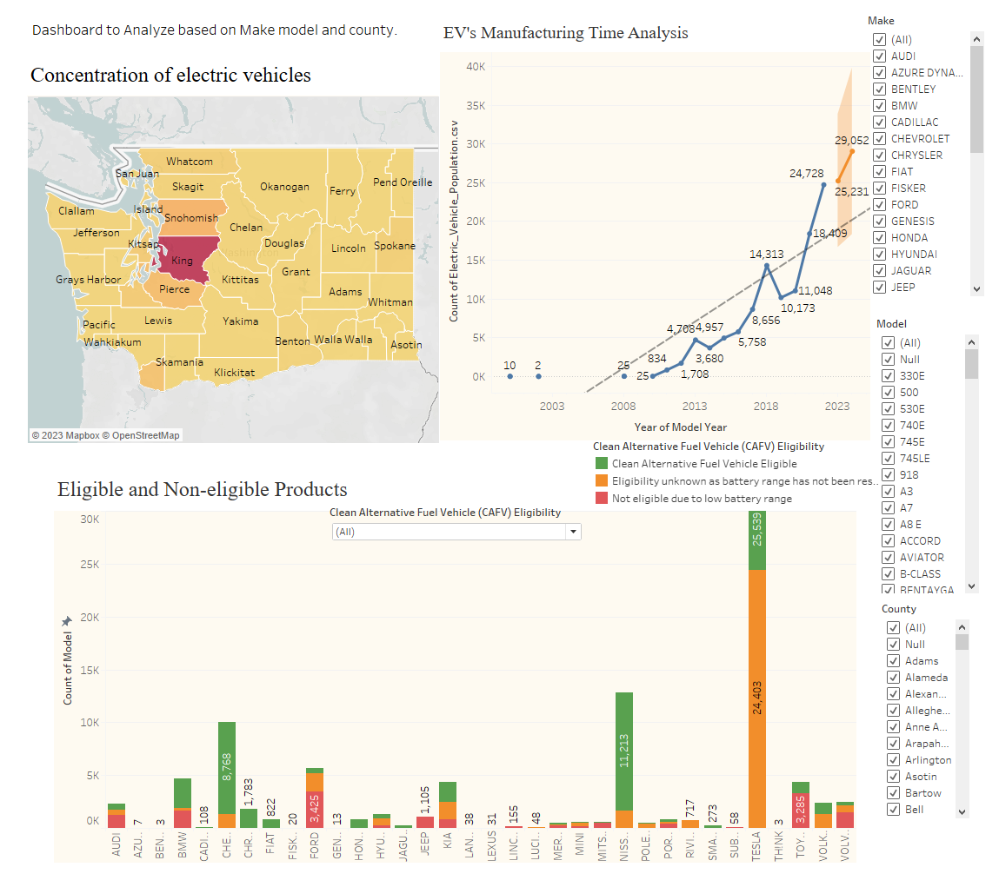

The Tableau dashboard titled "Dashboard to Analyze based on Make model and county" is a comprehensive visualization integrating multiple data views to analyze the electric vehicle (EV) market. It includes a map for geographic distribution, a line chart for manufacturing trends over time, and a bar chart for the eligibility of different EV models.

**Summary:**

1. **Concentration of Electric Vehicles (Map):**
   * This map visualizes the distribution of EVs across counties, using color intensity to indicate the concentration levels. Darker shades signify higher concentrations, which often correlate with urbanized areas or regions with better EV infrastructure.
2. **EV’s Manufacturing Time Analysis (Line Chart):**
   * The line chart tracks the production count of electric vehicles over model years, showing a clear upward trend in production volume. Peaks on the chart indicate years with significant increases, which could be attributed to advancements in technology, increased consumer demand, or policy incentives.
3. **Eligible and Non-eligible Products (Bar Chart):**
   * This bar chart categorizes various EV models into three groups: eligible for clean alternative fuel vehicle (CAFV) incentives, eligibility unknown, and not eligible due to low battery range. The height of the bars indicates the count of vehicles in each category, providing insights into the compliance of these models with environmental standards.

**Insights from the Results:**

* **Regional EV Adoption:** The map highlights regions with high EV adoption, which can guide infrastructure development, such as charging stations, and target areas for increased marketing efforts.
* **Growth Trajectory:** The manufacturing trend indicates a rapidly growing EV market, particularly in recent years. This growth reflects wider acceptance of EVs and possibly the influence of government policies promoting sustainable transportation.
* **Eligibility Status:** The eligibility bar chart reveals a significant number of EVs that meet CAFV standards, suggesting that manufacturers are increasingly focusing on producing vehicles that align with environmental guidelines. However, the presence of non-eligible models indicates that there are market segments or legacy models that do not meet these standards.

This dashboard provides stakeholders with a multi-faceted view of the EV market, combining geographical, production, and compliance data. It serves as an analytical tool to understand market dynamics and to make informed decisions regarding product development, marketing strategies, and policy-making in the realm of electric mobility.

**Dashboard 2:**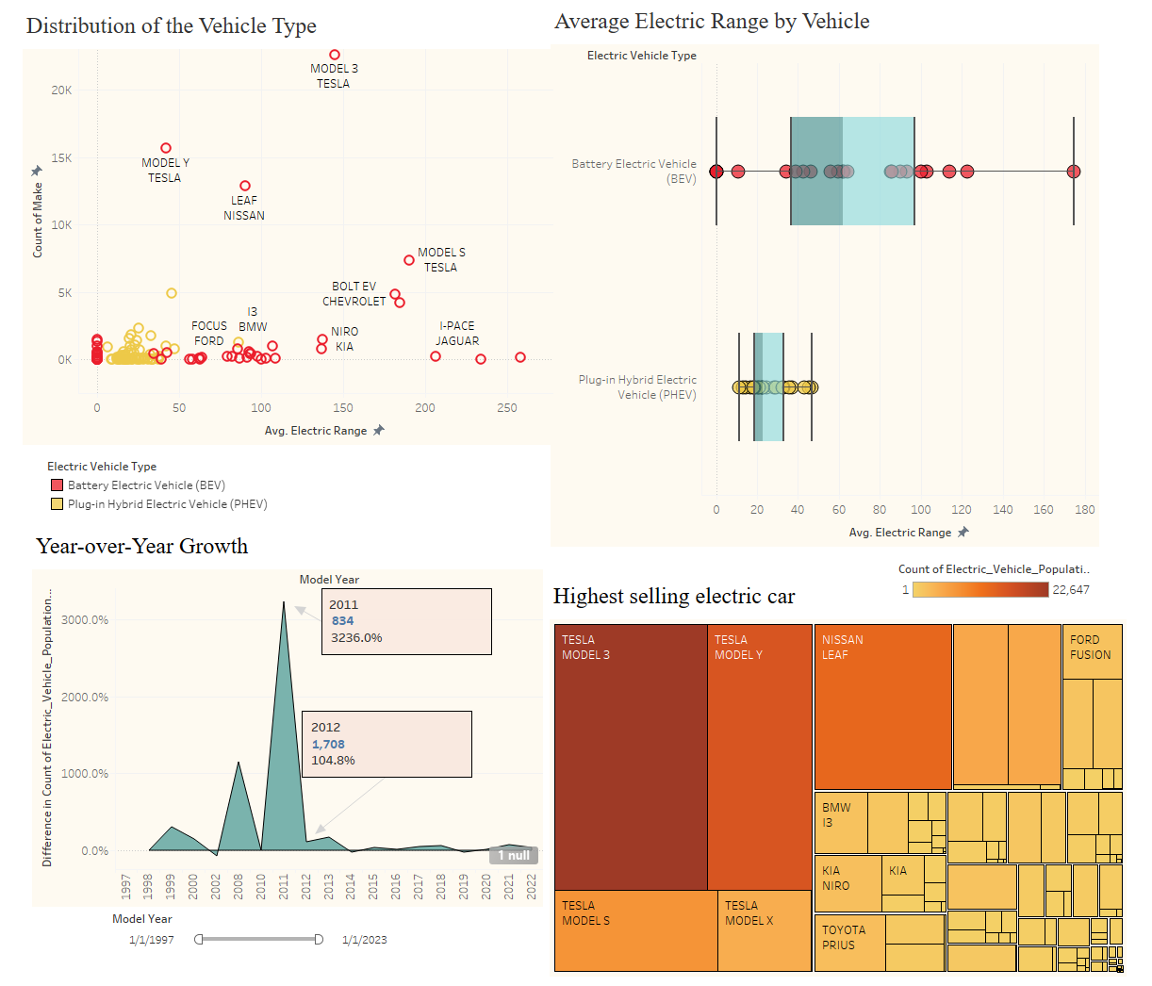

**Summary:** The dashboard consists of four main components:

1. **Distribution of the Vehicle Type (Scatter Plot):** This chart plots EV models based on their average electric range and the count of vehicles. Different symbols represent battery electric vehicles (BEVs) and plug-in hybrid electric vehicles (PHEVs). It allows for quick comparison of range versus popularity among the models.
2. **Average Electric Range by Vehicle (Box-and-Whisker Plot):** This visualization compares the distribution of the average electric range between BEVs and PHEVs. It uses a box-and-whisker format to show median, quartiles, and outliers in range data.
3. **Year-over-Year Growth (Area Chart):** An area chart shows the year-over-year percentage growth in EV production, highlighting significant changes over time.
4. **Highest Selling Electric Car (Treemap):** A treemap displays the relative sales volume of various EV models. Larger areas correspond to higher sales volumes.

**Explanation of the Visualization:**

* **Scatter Plot:** The horizontal axis represents the average electric range, while the vertical axis represents the count of models. This plot reveals the diversity of EVs in terms of range and how many of each model are on the road.
* **Box-and-Whisker Plot:** The plot divides the range of EVs into quartiles and shows the spread of ranges within BEVs and PHEVs, providing insights into their performance characteristics.
* **Area Chart:** The chart illustrates significant peaks and troughs, with the peaks likely reflecting years where either a breakthrough in technology, economic factors, or policy changes boosted production numbers.
* **Treemap:** Each rectangle in the treemap is sized and colored according to the sales volume of that particular EV model, making it easy to identify the market leaders.

**Insights from the Results:**

* **Vehicle Type Distribution:** BEVs generally have a higher average electric range than PHEVs, and the most popular models are those with higher ranges.
* **Electric Range:** BEVs offer a broader range of electric ranges than PHEVs, with some models significantly outperforming others.
* **Growth Dynamics:** There was an extraordinary spike in growth in the year 2011, suggesting a possible market shift or introduction of significant incentives or technologies that year.
* **Market Leaders:** The treemap shows that certain models, particularly from Tesla, dominate the market in terms of sales volume.

Overall, this dashboard offers a comprehensive look at the EV market, from detailed model analysis to broader trends in growth and market penetration. It can be used by stakeholders to make informed decisions regarding investment, development, and marketing within the EV industry. I have curated all of the dashboards in a sequence to create a storyline and created a story.

**VII. Building the Tableau dashboard in HTML web page:**

I have published the whole tableau workbook into the Tableau Cloud by logging in and activating the server. Then created a HTML file and embedded the tableau script tag into the HTML file. Then I restart the server using “python -m http.server 8000” in the terminal. The HTML file activated with D3.js code gets the Tableau published into the Localhost.

Localhost link:

[file:///C:/Users/Checkout/Desktop/SEM1/DATA%20230/Term_Project/Electric_Vehicles.html](C://Users/Checkout/Desktop/SEM1/DATA%20230/Term_Project/Electric_Vehicles.html)

Opening the HTML file give display of the whole Tableau Workbook project.

**Published dashboard link:**

<https://us-west-2b.online.tableau.com/t/yashasvidataviz/views/Electric_VehicleAnalysis_Sem1_project/OverallStory/c70789b2-ab11-48f6-8755-e716045d3a56/164fc032-9d75-4e7c-a190-7a6641272cdb>

**HTML code:**

<!DOCTYPE html>

<html lang="en">

<head>

<meta charset="UTF-8">

<title>Tableau Dashboard Embed</title>

<script type='module' src='https://us-west-2b.online.tableau.com/javascripts/api/tableau.embedding.3.latest.min.js'></script>

</head>

<body>

<div style="width:1000px; height:663px;">

<tableau-viz id='tableau-viz'

src='https://us-west-2b.online.tableau.com/t/yashasvidataviz/views/Electric_VehicleAnalysis_Sem1_project/OverallStory/c70789b2-ab11-48f6-8755-e716045d3a56/164fc032-9d75-4e7c-a190-7a6641272cdb'

width='1000'

height='663'

toolbar='bottom'>

</tableau-viz>

</div>

</body>

</html>

**Webpage link:** [**http://localhost:8000/wildfiretrends.html**](http://localhost:8000/wildfiretrends.html)

Screenshots of the Tableau project dashboard embedded in the HTML page and hosted into local host server.

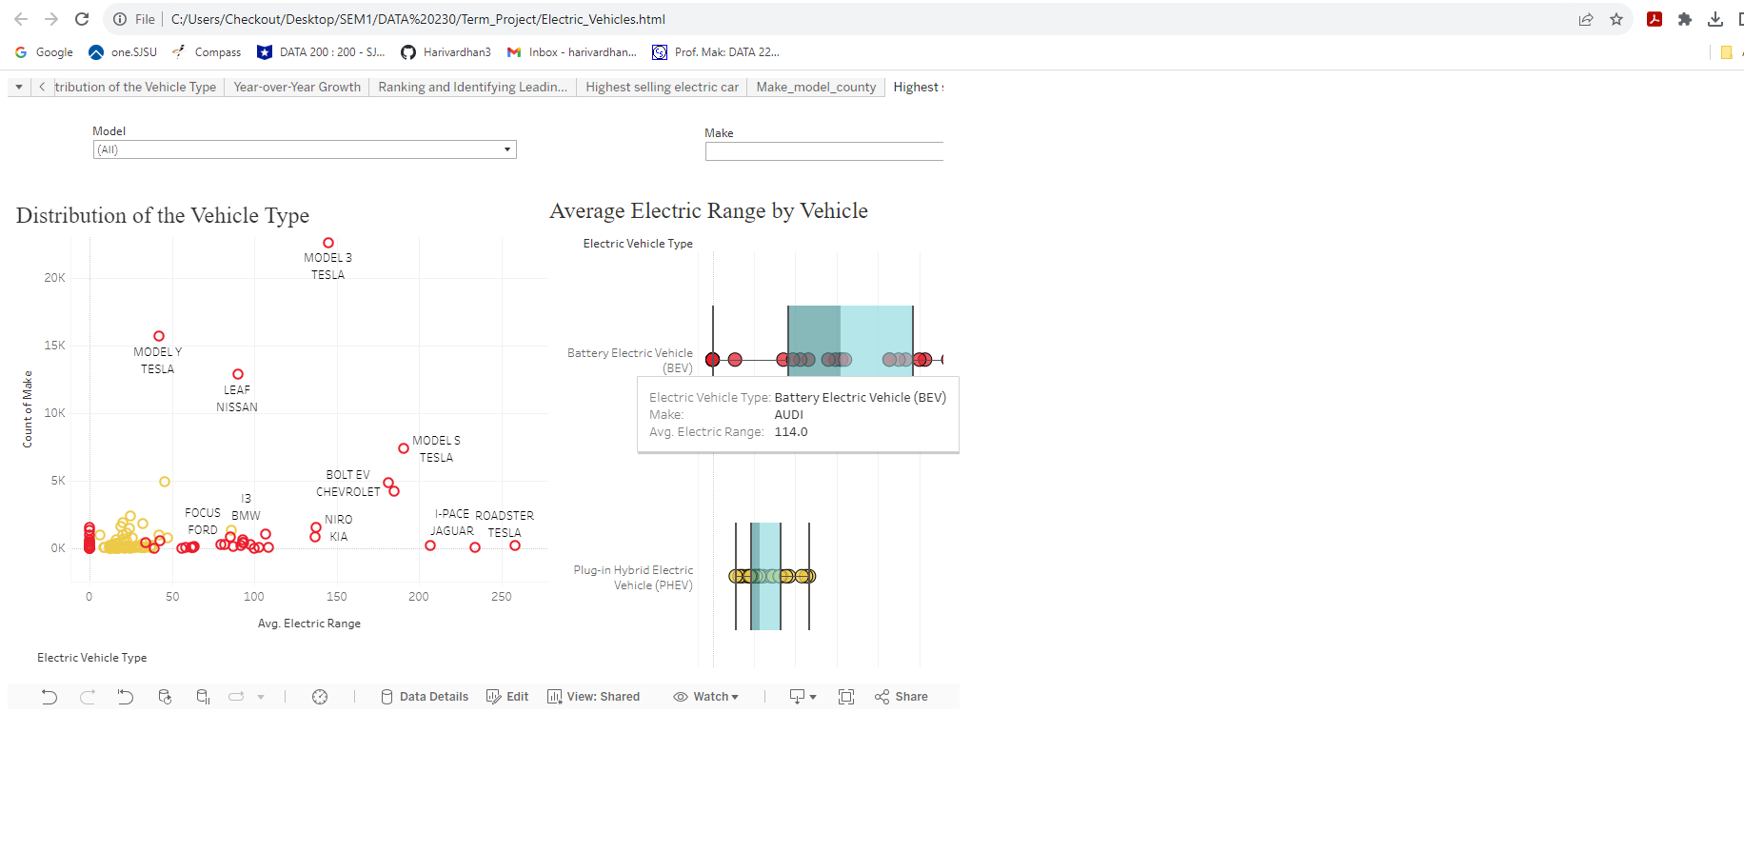

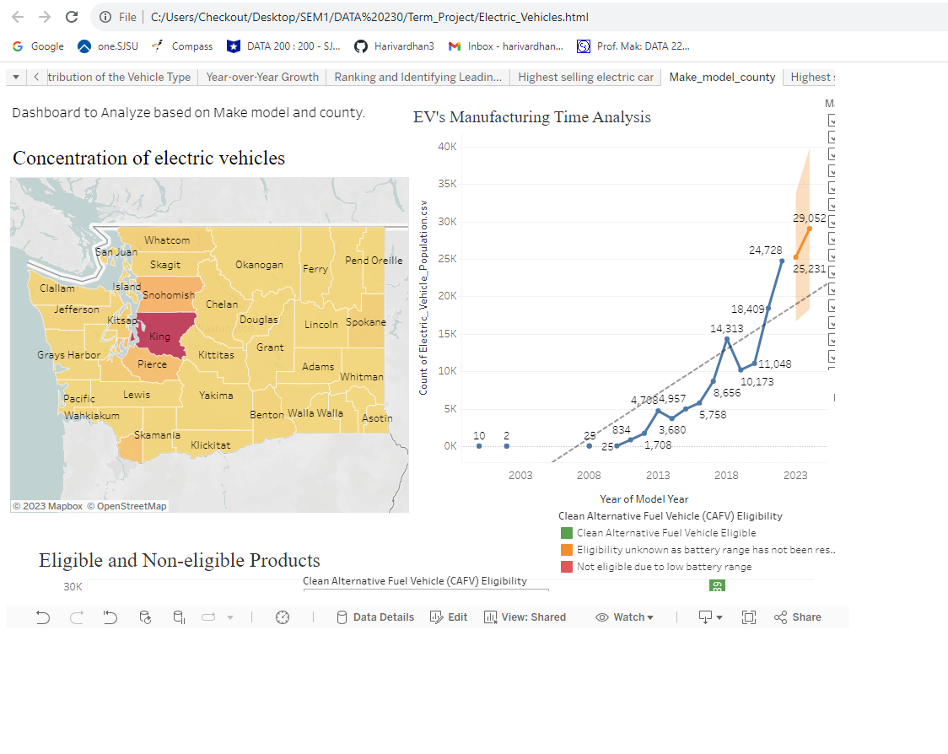

**VIII. Synopsis and Conclusions:**

The tableau visualizations and dashboards examined provide a multidimensional view of the electric vehicle (EV) industry, revealing patterns and trends in vehicle distribution, performance, manufacturing growth, and sales success across various models and regions. Through a series of maps, scatter plots, box-and-whisker plots, area charts, and treemaps, we delve into the intricacies of the EV market, uncovering the nuances of consumer preferences, the progression of vehicle technology, and the economic and environmental factors driving the industry forward.

In summary, the tableau visualizations underscore the dynamic nature of the EV market, characterized by rapid technological advancements, shifting consumer preferences, and an increasing drive towards sustainable and high-performing vehicles. The insights gained from this analysis could serve as a strategic guide for manufacturers, policymakers, and investors in navigating the evolving landscape of electric mobility.

**XI. References:**

[1] Citations: Yiwei Shi, Donghan Feng, Sumin Yu, Chen Fang, Hengjie Li, Yun Zhou,

The projection of electric vehicle population growth considering scrappage and technology competition: A case study in Shanghai, Journal of Cleaner Production, Volume 365, 2022,

132673, ISSN 0959-6526, <https://doi.org/10.1016/j.jclepro.2022.132673>.

[2] Jae Hyun Lee, Scott J. Hardman, Gil Tal, Who is buying electric vehicles in California? Characterising early adopter heterogeneity and forecasting market diffusion, Energy Research & Social Science, Volume 55, 2019, Pages 218-226, ISSN 2214-6296, https://doi.org/10.1016/j.erss.2019.05.011.

[3] https://catalog.data.gov/dataset/electric-vehicle-population-data

[4] https://data.wa.gov/Transportation/Electric-Vehicle-Population-Data/f6w7-q2d2/data